

How to Execute BVT (Build verification test) using Spritz

Firoj Patan

Navihealth

Contents

Start up 2

Record and Playback 4

Adding New Objects to the object Repository 7

Opening an Existing Project 8

Creating data sheets 9

Spritz BVT Project setup and execution 10

Reference 12

Start up

* Click on run.bat file to Open the tool

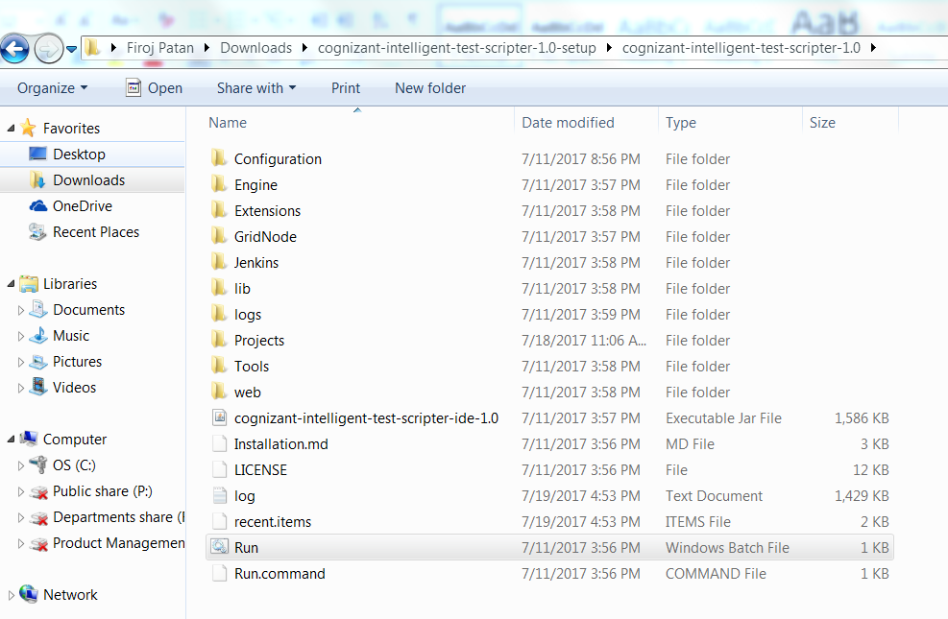

* Create new Project window will be displayed

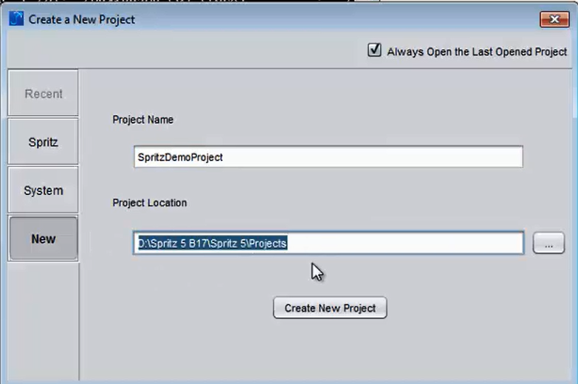

* Provide the new project name and location then click on Create New Project
* Tool will be opened with the New scenario and test case as shown below

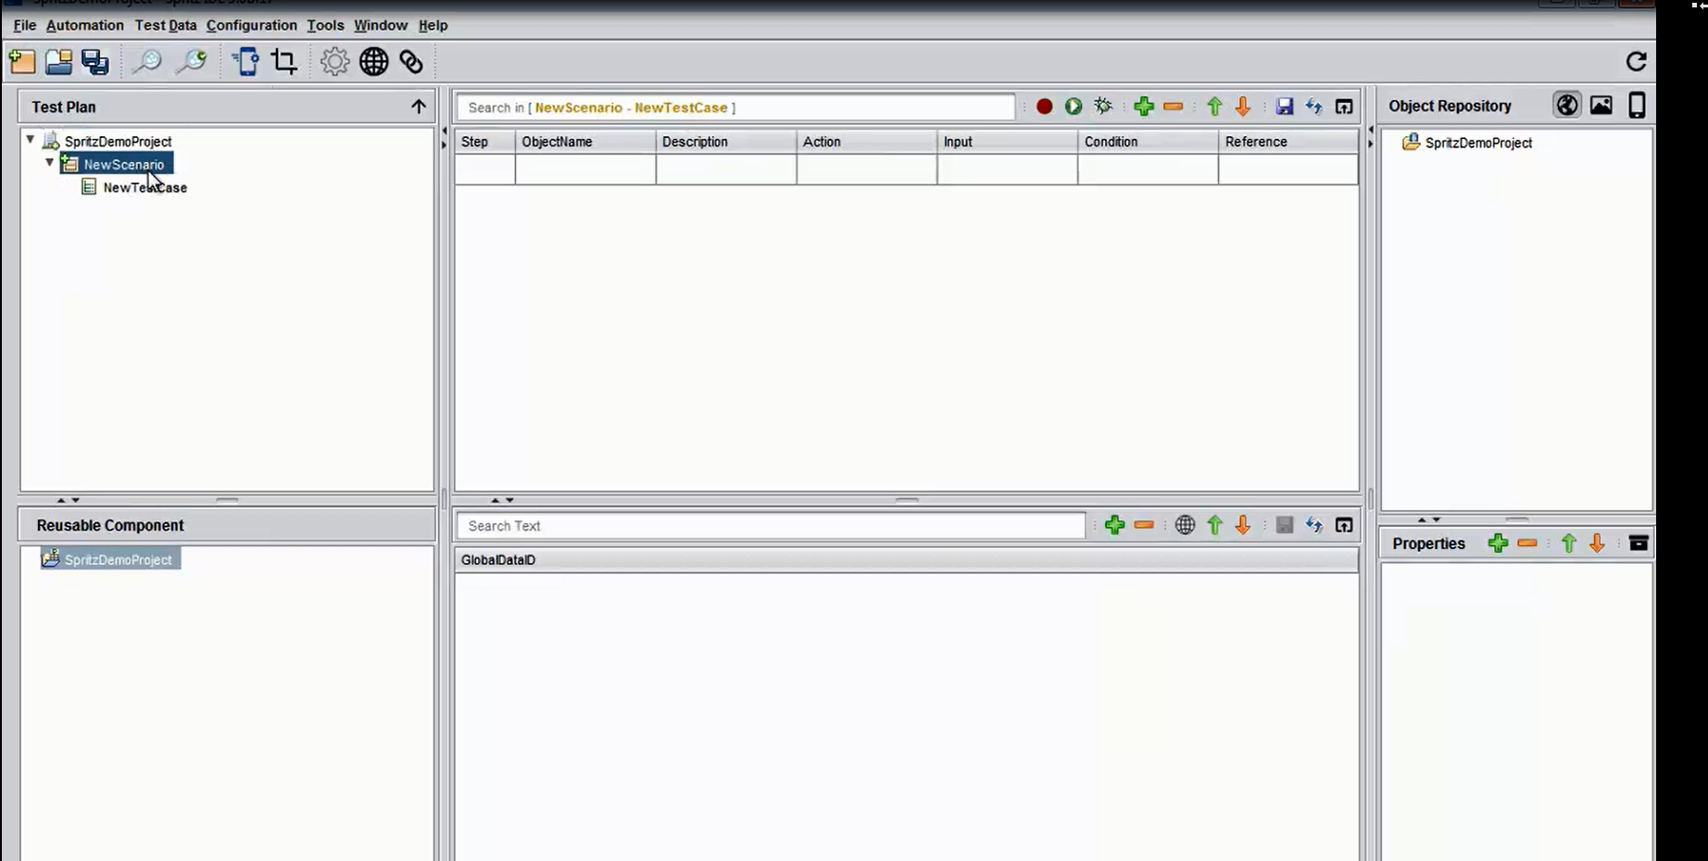

* User can rename the scenario and test cases.

Record and Playback

* Tool provides the recording option so that user can create the test case by recording a flow



* Before start recording user should be adding browser plugin. Example given for chrome
* Visit chrome://extensions in your browser
* Drag and drop cognizantits.crx into the browser to install (File is available in extension folder)
* Recording window will be displayed once you click on recording button.

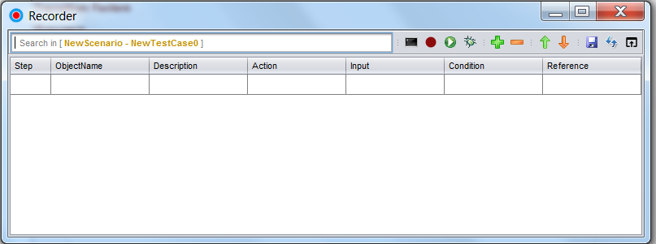

* Click on browser extension and perform actions on the browser so that each and every action is captured by the tool and they will display in the design window

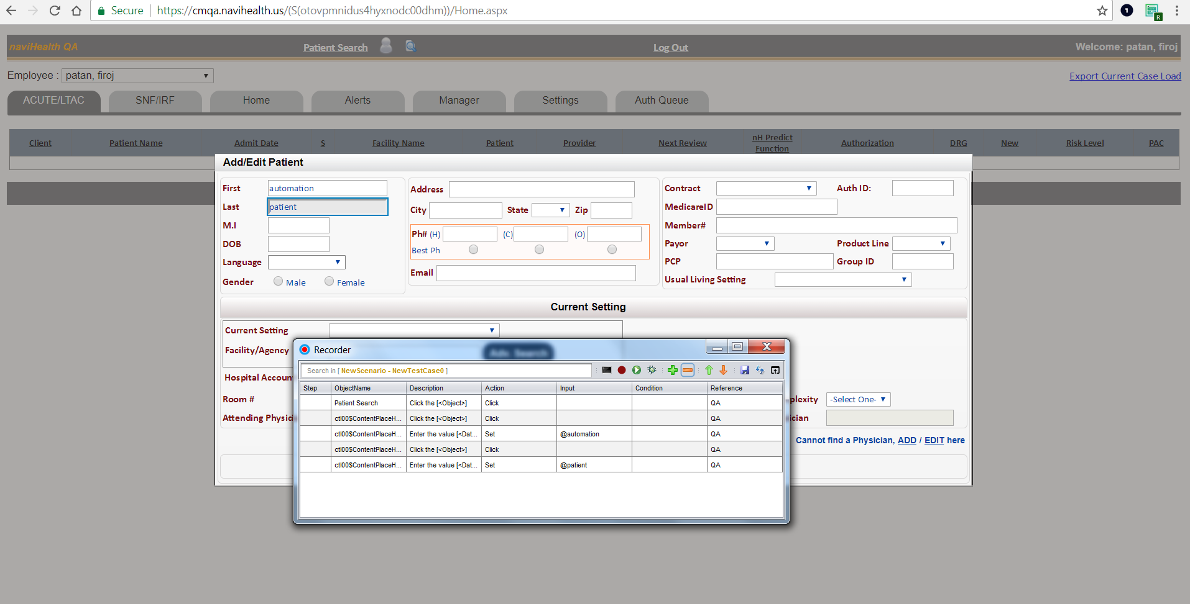

* Click on record button again to stop the recording.

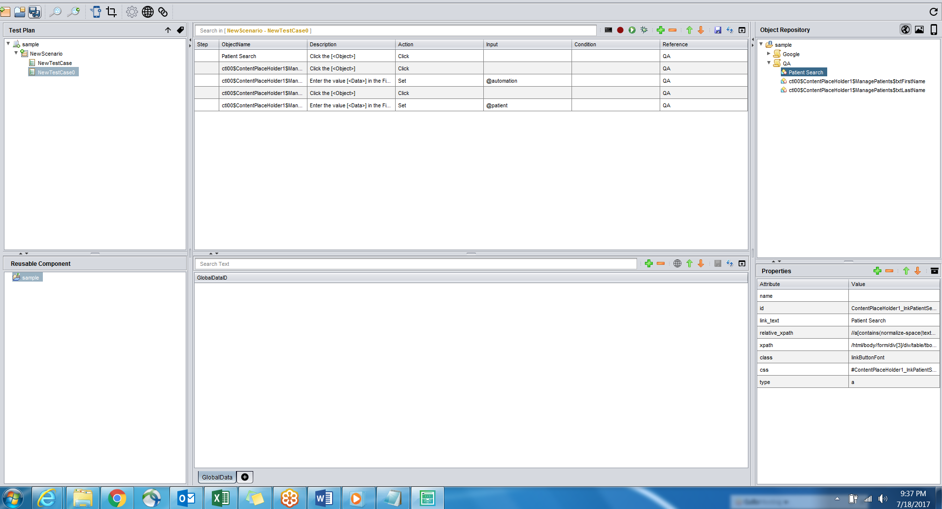

* All objects will be added in the object repository section page wise
* Below the Object Repository section, user can find the properties section which displays the properties of a selected object. User can even edit the property values
* All the steps will be displayed in the design section in the table format.
* Each row describes each step/action in the test case. User can add new step by clicking on Plus symbol.
* All the test cases will be created in Test Plan section
* User can create reusable flows by selecting the steps

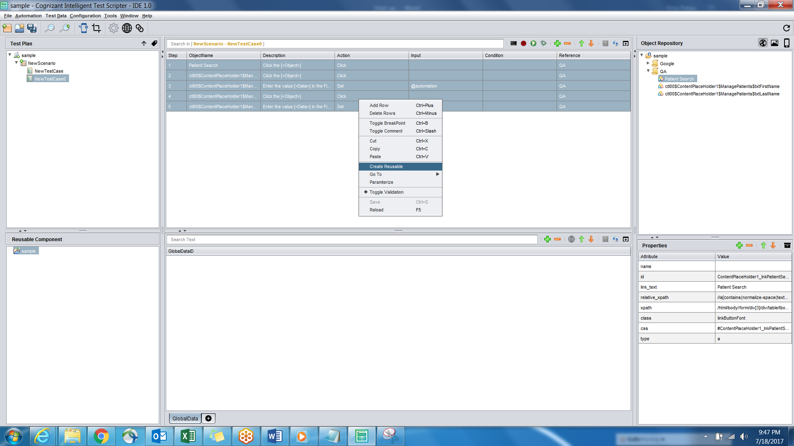

* Reusable flow will be added in the reusable component section and can be used in any test case
* Below user can find a data sheet section in which user provide data for test cases through parameters.

Adding New Objects to the object Repository

* User can add new object in the object repository using Object Spy.



* Click on Object Spy. Spy window will be opened.
* Navigate to the browser and click on extension present at top right corner.

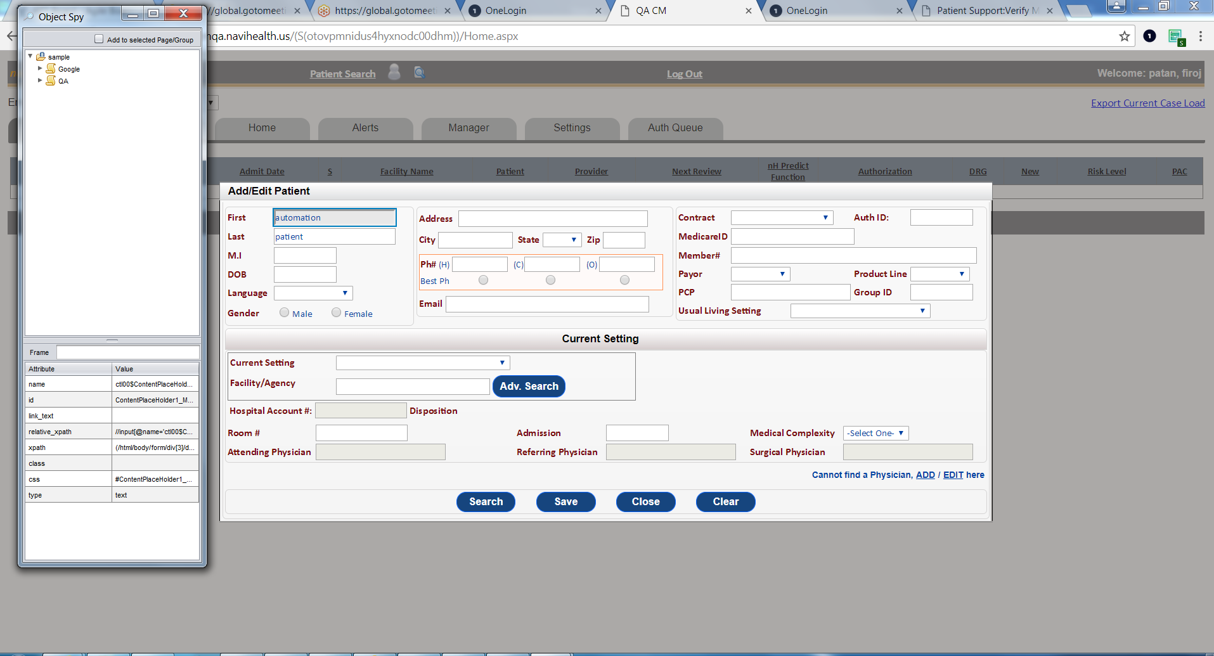

* Mouse hover the required field and press ctrl + right click so that object will be added in the object repository.

# Opening an Existing Project

* User can Open an existing project by clicking on File -> Open Project

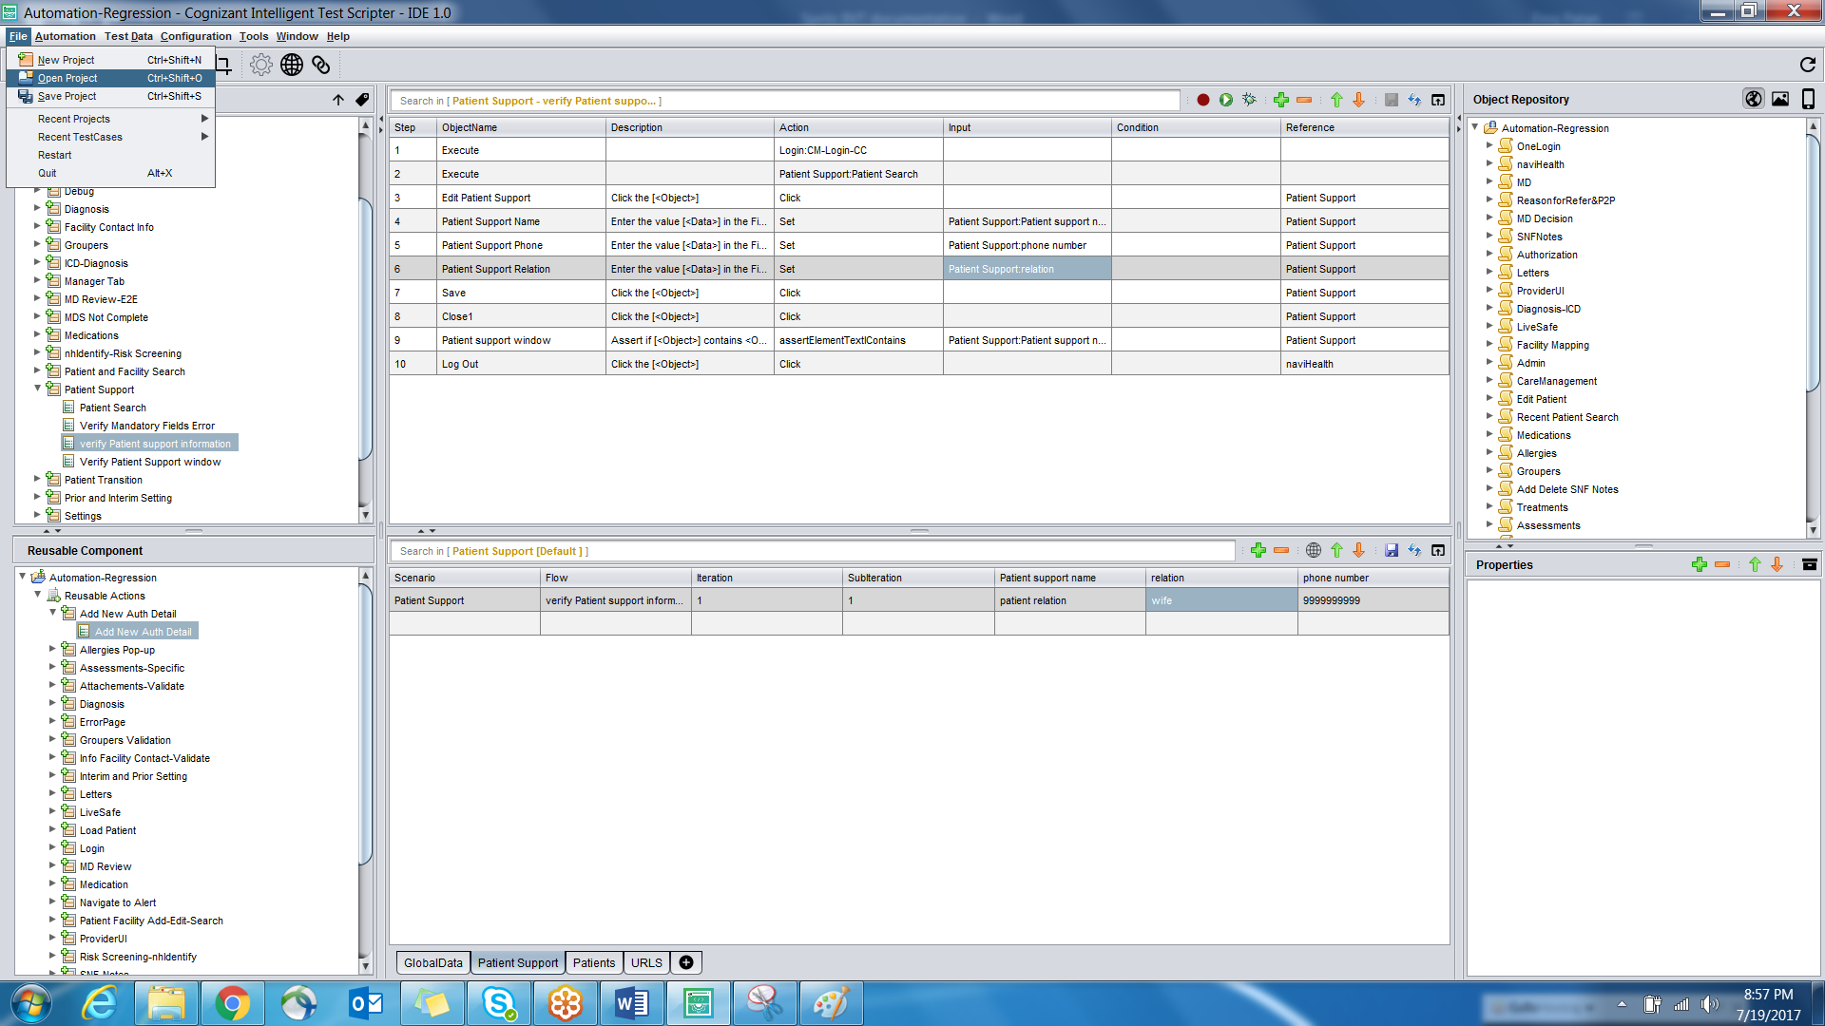

* Double click any test case to open in design view
* User can add a new step by clicking on plus symbol then empty row will be added below the selected step
* Drag and drop the object from object repository into the step. Select the action to be performed from the action column. (Ex set to enter text, Click to click).
* Enter data in input column if it is a text box. (Ex: @input).

# Creating data sheets

* User can add parameterized inputs by adding the data sheets
* Add a sheet in the data sheet section by clicking on + symbol and provide a name
* User can add any number of columns and rows
* Label the column name to the filed names and provide the data
* In test step input column, refer the data sheet to parameterize the input (Ex: datasheet name: column name)

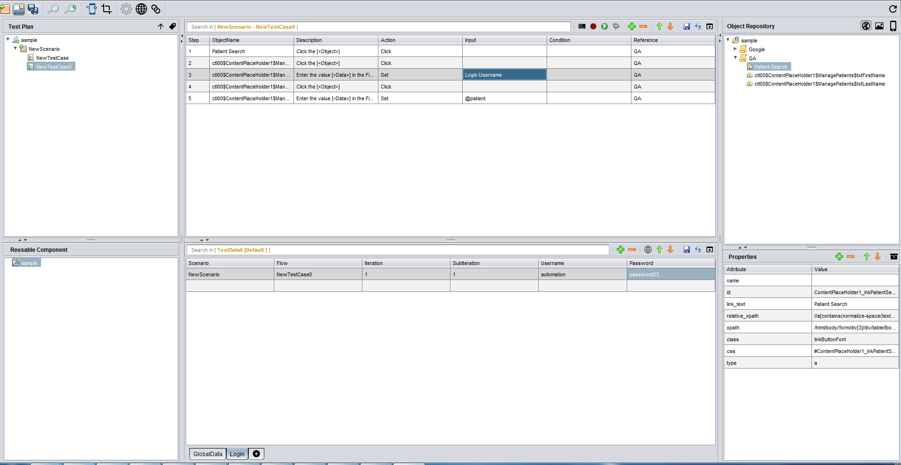

* To run the test case, click on run button present beside record button
* User can set browser option by right clicking the run button

# Spritz BVT Project setup and execution

* Open BVT project from File -> Open Project



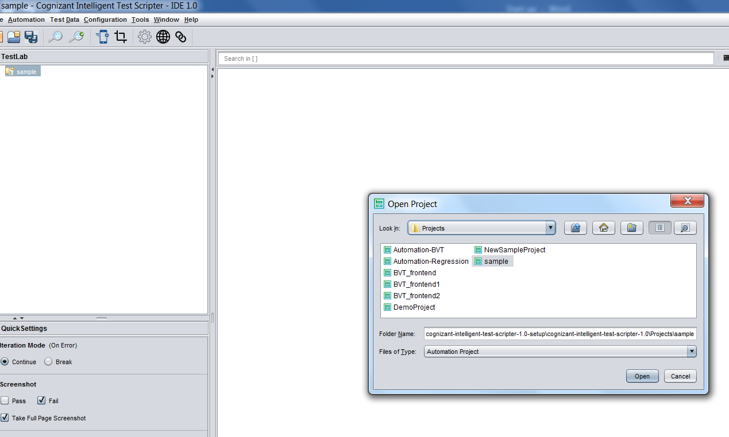

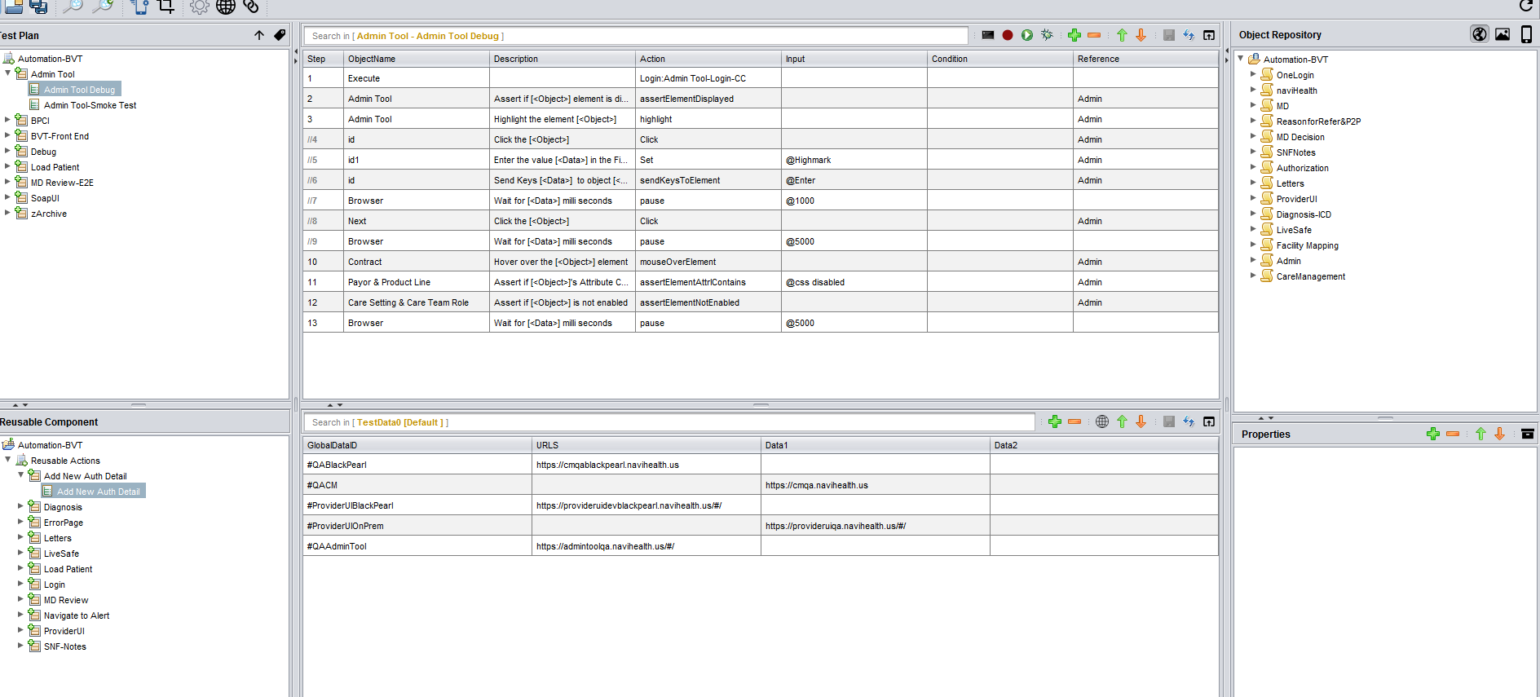

* Add a new test case if BVT criteria in met for that test case
* BVT uses chrome as default browser for execution
* User can create a suite to execute all the test cases as a suite. Navigate to Window -> Test Execution to open the execution window.

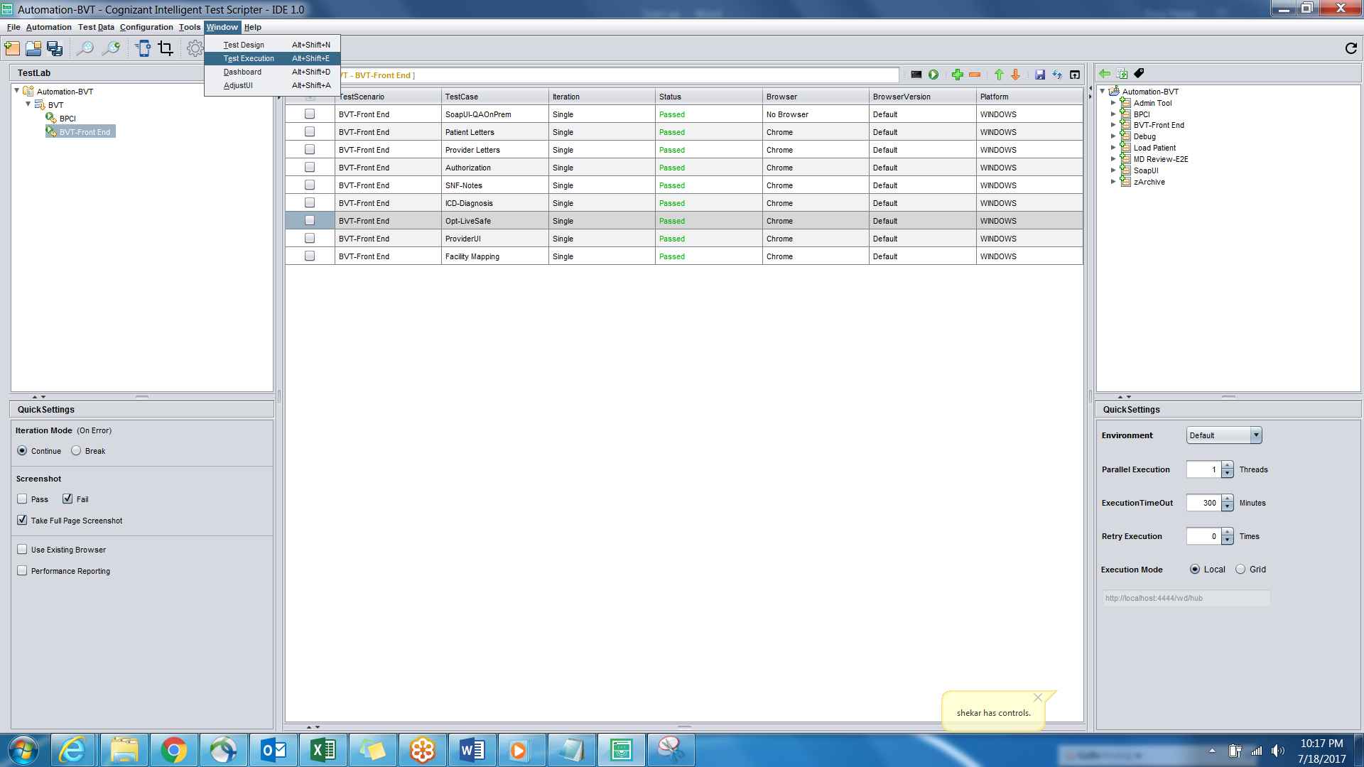

* All the test cases present in the project will be displayed right side section. User can drag/select them to execution section to add in the suite.
* User configure run settings in Quick Settings section. Even user can instruct the tool to select the browser for each test case from browser column.
* Click on run button to execute the entire suite.
* Results will be displayed in a browser once execution is completed.

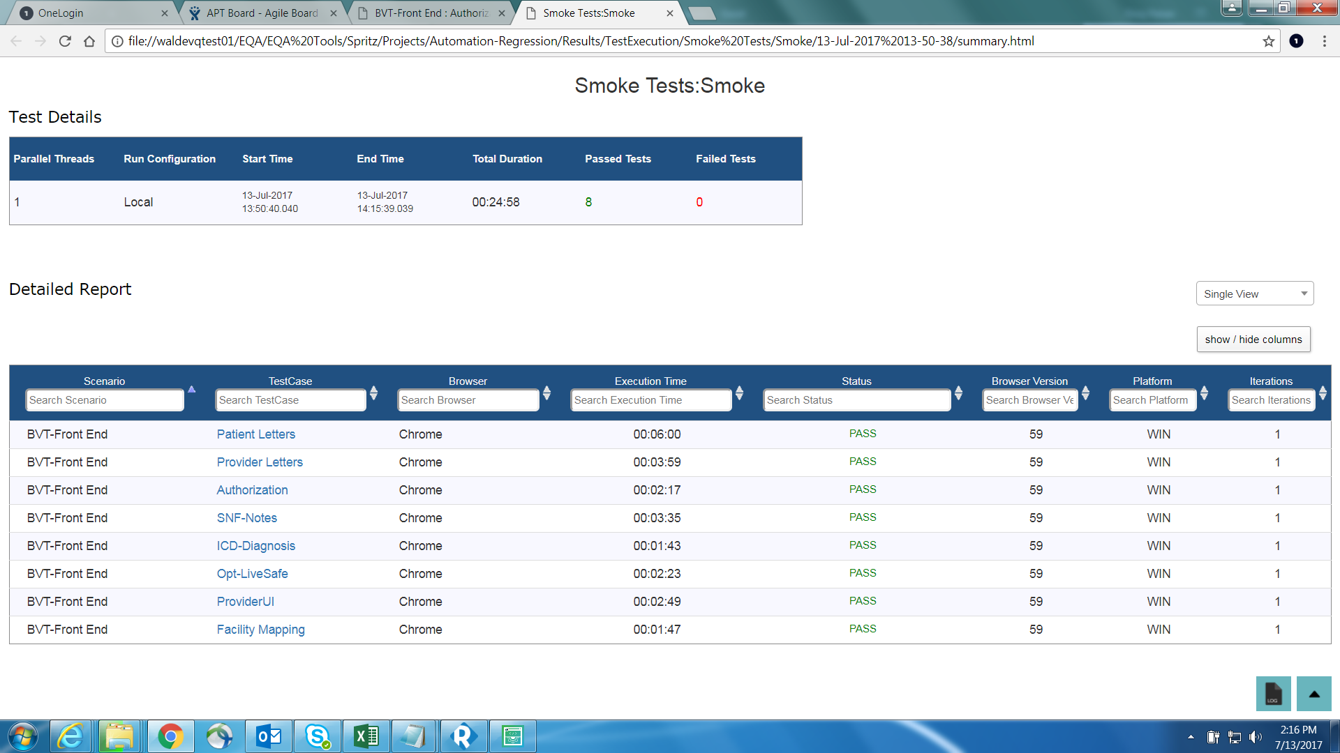

* Click on test case link to see the detailed report

# Reference

* Please kindly follow the below location for Spritz training demo videos
* P:\IT\QA\QA Automation\Spritz\Spritz training Demo videos